Use Case Diagram For Railway Reservation

|  |  |
| --- | --- |
| Use Case | Actor |
| 1.Login ,Update Profile  2.Mange Booking  3.Mange Application and Customer  4.Mange Tickets Payment,Schedule trains  5.Book Tickets  6.Make Payment ,Search Trains  7.Collect Payment and Search Vacant Seats | Ticket agent,Customer ,System User and Super Admin  Super Admin,System User  Super Admin  Super Admin,System User  Ticket Agent and Customer  Customer  Ticket Agent |

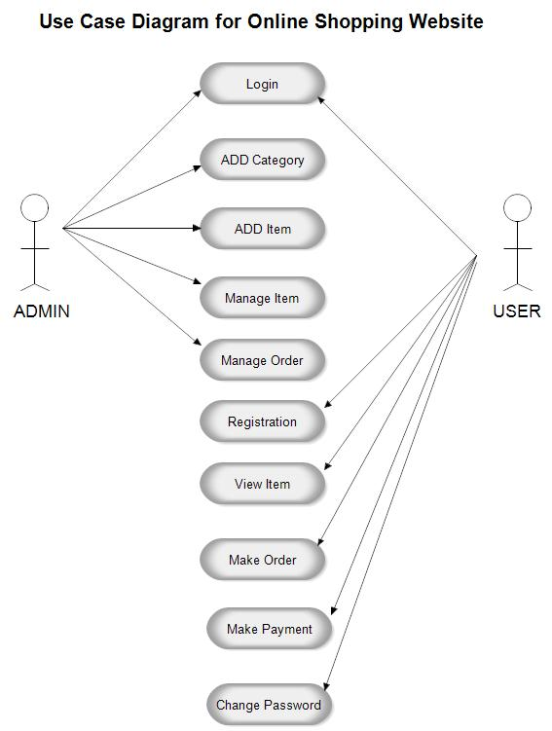

|  |  |
| --- | --- |
| Action | Software Reaction |
| Login & Update Profile | System Request to fill login details Such as  1.Username  2.Password  3. OTP(Optional)  4.Captcha  Valid Information is Mandatory |
| Searching For Trains | Application Request to fill correct information  1.Boarding and destination stations  2.Date  3.Class(AC,Non-Ac Etc)  4.Time |
| Payment | Make sure that user payment does on time ie 5 min for online |
| Collect Payment And Search vacant seats | Collection of Payment through Online and Offline  Searching Remaining vacant seats and cancel seats |
| Mange Full application and user  Mange Booking  Mange Customer | Its Done by admin  Admin handle whole application and user interface sometimes if any query occurs  Manage the database also  If booking shows query it immediately goes to the admin  Such as Booking fails  Mange Customers means managing there queries  Eg  Payment done but Booking fails |
|  |  |
|  |  |

Customer

System User

Super Admin

Ticket Agent